Maria Merino

3rd Phase Challenge:

Section 1 - Getting Started
1.2 Creating your first application
Q: Create your first application using the same steps Simon describes in the video. Familiarize yourself with the Xcode environment and specifically notice how it can be manipulated to display different helper tools and how it will attempt to fill in your code as you type it.
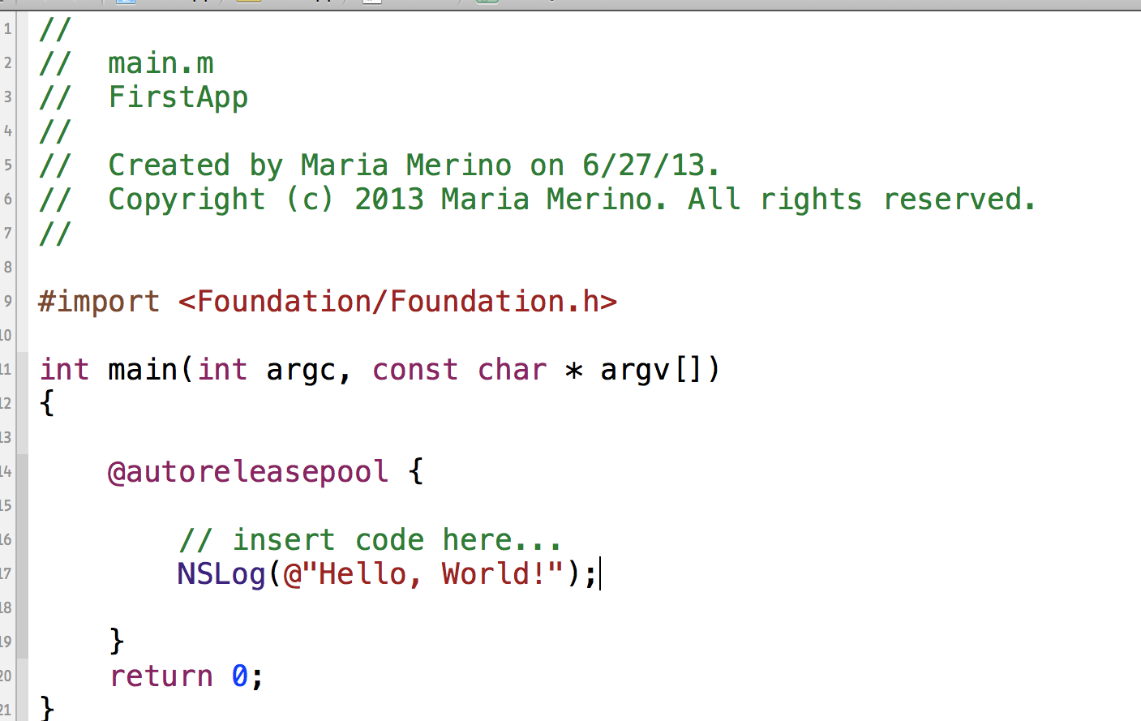
1.3 Updates to this course
Q: Why do you think it's important to be aware of the idiosyncracies with older versions of Objective-C and to keep up with new features as they are added?
It’s important to be aware of the idiosyncracies with older versions of Objective-C along with keeping up with new features so that we can coincide with the new mac or the iOS operating system.

Section 2 - Objective-C Basics
2.1 The Objective-C language
Q: How did Objective-C become the language to learn if you want to make apps for the iPhone and iPad?
Because Objective-C is built on a historical necessity built by Mac for almost 20 years. Objective-C is the primary language that powered up all iOS frameworks and apps along with the Cocoa touch frameworks.
2.2 The structure of an Objective-C program
Q: Create a new project. Go to the menu option Xcode/Preferences/Text Editing and make sure "Line Numbers" is checked in the section marked "Show." Then add comments describing the purpose of each auto-generated line in the main.m file. For example on Line 17 I would write: " NSLog(@"Hello, World!"); //instructs the console to output the phrase "Hello, World!")"
2.3 Compiling and running your code
Q: Why might you build in one version of iOS but deploy in an older version?
You might want to build in one version of iOS but deploy in an older version so that you are able to test your app on several devices and iOS versions as well.

Section 3 - Program Flow
3.1 Logging messages to the command line
Q: Following the example in the video, write a program that calculates and outputs to the console the number of seconds in ten years. Copy and paste your code here.
//
// main.m
// FirstApp
//
// Created by Maria Merino on 6/27/13.
// Copyright (c) 2013 Maria Merino. All rights reserved.
//

#import <Foundation/Foundation.h>

int main(int argc, const char * argv[])
{

// insert code here...
int seconds = 60;
int minutes = 60;
int hours = 24;
int days = 365;
int years = 10;

int secondsInTenYears = seconds * minutes * hours * days * years;

NSLog(@"There are %i seconds in Ten years.", secondsInTenYears);

return 0;
}

3.2 Writing conditional code
Q: Using Objective-C, create an integer variable called "day" that represents the days of the week. Write an if statement that checks whether "day" is a weekend day. If the day is weekend days then have your program print a message saying, "Have a nice weekend!" and if it's not, print a message saying, "I hope you're having a good week!"
int day = 7;

if (day <= 5 ) {
printf("Hope you're having a good week!");
} else {
printf("Have a nice weekend!");

}

}
return 0;
}
3.3 The switch statement
Q: Create a variable called "hurricaneCategory" and a switch statement that prints out a message describing a hurricane's category from 1-5.
int hurricaneCategory = 3;

switch (hurricaneCategory) {
case 1:
NSLog(@"It's a Category 1 Hurricane!");
break;
case 2:
NSLog(@"It's a Category 2 Hurricane!");
break;
case 3:
NSLog(@"It's a Category 3 Hurricane!");
break;
case 4:
NSLog(@"It's a Category 4 Hurricane!");
break;
case 5:
NSLog(@"It's a Category 5 Hurricane!");

}

}
return 0;
}
3.4 Code snippets
Q: Grab a code snippet, indent it to match the indent of your project, then add comments to it, then select the entire snippet you just modified and save it as your own code snippet. Time yourself and record how many seconds it takes you to do all this.
30 seconds.
3.5 Operators and expressions
Q: List the 6 types of operators described in this video. Provide their name, a description of their meaning, and the syntax you would use to execute them. What code snippet does the ternary operator replace?
6 types of operators are:
Arithmetic (+=, -=, *=, /=). They are called single operators.
Comparison. ( ==, !=, >, <, >=, <=). They are also single operators and they are used to compare equality and the return would be either a true or false statements.
Logical and/or. && represents and || represents or. They are single operators used for multiple conditions.
Modulus- (%). This is used to calculate a remainder. This also works only with integers and even numbers.
Increment/Decrement- (=, +=, ++(unary), -, -=, --).
Ternary. Has three parts with two symbols, (?) and (:). Ternary replaces the ‘if and else ‘statement.
3.7 Functions
Q: What is a function? What is a function prototype? What are the purposes of each? What are the rules for when and how you can call a function?
A function is a name associated with a chunk of related code. A function prototype is a description that a function exists, what it returns and accepts but nothing on the body. A function must have a return type, and the parameters (type of data the argument represents and the name of the parameter. Functions are declared in a class, independent of an instance.
Section 4 - Variables

4.1 Data types
Q: What are the primitive data types in Objective-C? Why did Apple add a set of classes to handle other data types?
Primitive data types in Objective-C are:
int, float, double, char, and BOOL. Apple added sets of classes to handle other data types such as NSString and NSDate to make it easy to work with strings, dates, and many more complex types.
4.2 Working with numbers
Q: Make a table of Objective-C primitive data types. Add numeric data types and their properties to this table.
int- ~2 -4 bytes
float – 4 bytes
double – 8 (double the amount)

4.3 Working with characters
Q: Add char and BOOL (the character data types) to your table created above.
char- single byte
BOOL –Yes or No
4.4 Variable scope
Q: Describe in your own words what the scope of a variable is in Objective-C
The scope of a variable is where it is visible and accessible. By default, it exists inside the statement block defined in. For an example, if the variable is created inside a function, variable is only available inside that function.

4.5 Enumerations
Q: What does "enum" allow you to do?
Enum allows you to define your own data type.

4.6 Using typedef
Q: When would you define your own data type versus using an enum?
Creating an enum defines our data type. But defining your own data type makes it easier to create variables of that type compared to saying enum of ‘something’.

4.7 Preprocessor directives
Q: Describe the three common preprocessor directives, #import, #define, and #if DEBUG. Come up with one example where you would use each.
#import requests that the preprocessor reads a file and then adds it to its output. For an example, using #import <Foundation/Foundation.h> to connect to the Foundation framework.
#define can be used to make something like a function. For an example, when you want to create a value and give it a name. #define LOWSCORE 10000
#if DEBUG allows us to have a conditional code where it causes something to happen before the code is executed. For an example, if you want to check if you are in compiled in debug mode.
#if DEBUG
NSLog(@”The maximum value of an int is %1”, INT_MAX);
#endif

4.8 Working with strings
Q: Define the same string using both NSString and C-style string syntax. Describe the purpose behind each part of your definition.
String message =Hello”;
NSString *message = @”Hello”;
NSString is the type, * is the pointer, message is the name of the variable, and @”Hello”; is the value. NSString is part of the foundation framework. It links to all the extra code so that we have a string data type to work with NSString.

Section 5 - Classes
5.1 Introduction to object orientation
Q: Create an encapsulated (including generalized attributes and behavior) description of a "mobileMakersParticipant" class. Instantiate a single object representing yourself as a member of this class.
MobileMakersParticipant class
Attributes: gender, age, programming experience,
Behavior: learn, code, eat, talk, drink
5.2 Using objects and pointers
Q: What is the pointer's role in instantiating an object from a class? How is a pointer different than a primitive?
Pointer’s role in instantiating an object from a class allows the address of the object to get passed around. Pointer is used as a reference or defines an object while primitives are value types.
5.3 Messages and methods
Q: What is the main difference between Objective-C's messages and method calls in other languages? How can this difference be seen as an advantage while programming?
In Objective-C, methods uses square brackets while methods in other languages use dot syntax. This is an advantage because even if it gives you a lot of code to read, it becomes more readable in an actual program compared to a smaller method call where you are just passing multiple parameters and you don’t know what those parameters are.
5.4 Using existing classes in the foundation framework
Q: What's the difference between a class method and an instance method? EXPLORE: Try typing "NSD..." into your code window. Use the auto fill feature and select a single class name that starts with those three letters. Once the name has been auto-completed, use the handy shortcut (Option + click) and investigate the class whose name just got printed to the screen. Examine the task list for this class. Do this a few more times until you're familiar with the process, or until you've exhausted your curiosity, whichever comes last.
Class method can be used with just a class name while an instance method uses an instance of a class.
Section 6 - Memory Management
6.1 What's new with memory management?
Let it soak in. No questions for this one.
6.2 Memory management in Objective-C
Q: What is the relationship between a pointer to an object, a block of memory, and the owning and releasing process? Can you come up with an analogy for this relationship?
Objective C uses reference counting where a line of code is used to create an object. An area of memory is then available for objects to be used. A pointer is used to an area of your memory where the object gets a retainCount (a number). An object gets a retainCount of 1 once it is created where you start working with the object using the square brackets [] to call methods using the pointer and when it is finished, you issue a call to release the object and the retainCount goes back to 0.
6.3 Object creation
Q: What does the new method do when used to create an object instance of a class? Why do we avoid using this method? How long is an object's lifetime?
The new method has two stages: allocation and initialization where it would first to ‘alloc’, which would return the instance, and then to ‘init’ the instance. Avoiding this method would help us control the instantiation and the initialization of an object. Automatic Reference Counting (ARC) evaluates the lifetime requirements of your objects where it automatically inserts memory management calls at compile time.
6.4 Using autorelease pools
Q: How does the autorelease pool work? How and when can you use it deliberately?
Autorelease means releasing the object later where it adds an entry to the auto release pool and adds it on that list. You can use it deliberately at the end of an event loop such as touching the button in an application.
6.5 Apple autoreleased objects
Q: What does NARC stand for? Why is it important to remember this?
NARC stands for new, alloc, retain or copy. This is important to remember because if you don’t use NARC that means you don’t own that object. It also helps you release an object that you don’t need anymore without using the autorelease option.

6.6 Introduction to Automatic Reference Counting (ARC)
Q: What does ARC save us from having to do? How does it keep us from having to make this extra effort?
ARC helps generate appropriate dealloc methods for us. ARC evaluates the lifetime requirements of your objects and will insert appropriate memory management calls automatically at compile time.
6.7 What does ARC manages?
Q: What are the differences between ARC and garbage collection? What makes these differences advantageous?
ARC will generate the code to release the object and the memory will be reclaimed. ARC is done at compile time not at runtime. Garbage collection is runtime technology that will impact your performance negatively. With garbage collection, objects can remain in the memory until the garbage collector does sweeps and finds its objects that no longer have references.
6.8 The rules of ARC
Q: Why can you not release or dealloc memory when working with ARC?
Because ARC is doing the memory management methods. You can’t manually release or dealloc memory with ARC.
Section 7 - Custom Classes
7.1 Creating your own classes
Q: What are the two different sections used to create a class? What do they hold and what files are they placed in? CHALLENGE: Create a Tweet class for a twitter style app.
The two sections used to create a class are: interface and implementation. Interface is done in a dot h file (.h file) where it announces what this class promised to do, what methods it has, or what properties are available. Implementation is done in a dot m file (.m file) where the real work is done. This is the real code of the class.
@interface Tweet class : NSObject
@property NSString *name;
@property NSString *title;
@property NSString *tweets;
@end
7.2 Defining methods
Q: CHALLENGE: Define what should get passed in and what should get returned by each of your methods in your Tweet class above.
Fetchtweets should be defined (- (void) fetchtweets)
and tweets should be returned (return tweets.count;)
7.3 Defining properties
Q: How did Objective-C programmers handle instance variables before 2012? How are they handled now? What got easier and what got obscured?
Before 2012, in order to define your classes, an instance variable needs to be defined inside your user interface where they are defined as regular variables. Few years ago, Objective-C added the idea of properties with new keyboard @property, which functions to automatically generate or synthesize accessor methods. In the mid 2012, Apple’s best practices is not to have any instance variables in your interface so curly braces are no longer needed. That means you just create all your publicly accessible data using the @property statements, which matched the @syntheisize statements in Xcode.
7.4 Defining initializers
Q: What are initializers and why do we need to use them? Describe a situation when you can rely on the standard init method and when you have to create your own custom initializer.
Initializers allow you to init the class with variable data. Standard init method is used when you don’t need to add an entry in the interface for init because that’s already defined in the NSObject. You use the custom initializer if you have initialization tasks where you need to be adding more parameters to your classes.

7.5 Using dealloc
Q: Why can we have a dealloc method in a class when using ARC, but we can't call dealloc manually ourselves when using ARC?
The dealloc method won’t work when ARC is turned on for your project because you yourself are not allowed to call a dealloc method of any object. Instead, Objective-C runtime would call the dealloc method when it recognizes it.

Section 8 - Collections
8.1 Working with C-style arrays
Q: What are the three constraints when using C-style arrays? Create a C-style array that holds the days of the week.
Three constraints are no bounds checking, fixed size, and can’t mixed types.
NSString *daysoftheweek[7] = {@"mon",@"tues",@"wed",@"thurs",@"fri",@"sat",@"sun" };
NSLog(@"The third string element is %@",daysoftheweek[2]);
8.2 Working with Objective-C array objects
Q: What is the difference between a mutable and an immutable array? CHALLENGE: Create an immutable array containing the days of the week. Create a mutable array that contains the days of the week that you will be at Mobile Makers. Add the days of the week from the immutable array to the mutable array.
A mutable array is a subclass of NSArray where it can do all the things NSArray can do along with extra functionalities. An immutable array is unchangeable. Once it’s created, you can’t add or remove object, as it is a fixed size.
NSArray *daysOfWeek=[NSArray arrayWithObjects:@”Monday”,@”Tuesday”, @”Wednesday”,@”Thursday”, @”Friday”, @”Saturday”, @”Sunday”, nil];

NSMutableArray *daysOfWeekAtMobileMakers = [NSMutableArray arrayWithObjects: @”Monday”,@”Tuesday”, @”Wednesday”,@”Thursday”, nil];

[daysOfWeekAtMobileMakers addObjects: @”Friday”, @”Saturday”, @”Sunday”];

8.3 Using dictionaries
Create a dictionary that lists five or more events in your life and the accompanying year (or date if you want to get fancy) of the event.
NSDictionary *events =
[NSDictionary dictionaryWithObjectsAndKeys:
@"Birthday", @"06/02",
@"Graduation", @"12/15",
@"Anniversary", @"05/14",
@"Promotion", @"6/18",
@"Mobile Makers", @"7/08",

nil];

NSString *someevents = @"6/02";

NSLog(@" %@ is for %@", someevents, [events objectForKey:someevents]);

}
return 0;
}
8.4 Fast enumeration
Use fast enumeration to log the timeline of the life events you described above to the console.
NSMutableDictionary *events =
[NSMutableDictionary dictionaryWithObjectsAndKeys:
@"Birthday", @"06/02",
@"Graduation", @"12/15",
@"Anniversary", @"05/14",
@"Promotion", @"6/18",
@"Mobile Makers", @"7/08",
nil];
//
[events setObject:@"Birthday" forKey:@"2nd"];

for (NSString *eventsnumber in events) {
NSLog(@" %@ is for %@",eventsnumber, [events objectForKey:eventsnumber]);

}
return 0;
}
Section 9 - File Management
9.1 Introduction to file management in Objective-C
What can you do with files using the methods you are aware of that are available in Objective C's Foundation class.
We can create an NSString to hold paths, grab attributes of that file using NSDictionary, or change its name using fileManager.
9.2 Working with paths and URLs
What are the three parts of a URL? What are the advantages to using NSURL?
URL is the location of a resource. Three parts of a URL are scheme (http), domain(www.something.com), and the path. Advantages to using NSURL are its more efficient as it’s faster than using string paths, can catch errors, and are used by more classes.

9.3 Reading and writing strings
What would be a reason you would want to write a string to disk instead of just keeping it memory?
The reason you would want to write a string to disk instead of just keeping it on memory so that you can declare that property and access that file using a standard format.
9.4 Archiving objects
Why would you want to archive an object instead of writing the data to disk using the techniques discussed previously?
You want to archive an object so that you can track changes of an object, encode and object using NSKeyedArchiver and decode an object using NSKeyUnarchiver.

Section 10 - More Complex Classes
10.1 Inheritance and NSObject
How can you determine what methods you're inheriting from a super class? How do you override a method inherited from a super class?
You can determine the methods you’re inheriting from a super class using the options on Xcode such as from NSObject. You can override a method by writing a method in your new class implementation using the same signature as the one in the super class.
10.2 Extending classes with categories
What is the difference between a category and an inheritance? What are the limitations of using a category?
Categories allow us to add our own methods to en existing class without modifying the class itself. It also binds methods to a class. Inheritance is used when you want to add something to an existing class that has a change of behavior of that class. One limitation of using a category is that you can’t add new instance variables but only methods instead.
10.3 Defining protocols
How are protocols useful?
Protocols specify that methods a class will implement. Protocols are used to declare sets of methods that a class must implement.

10.4 Dynamic typing
What are the advantages and disadvantages to dynamic typing?
Advantages for dynamic typing is that is it simple to use. Using the type id, for an example, will declare a variable that can hold a reference to any type of object.
Disadvantages for dynamic typing is the possibility to send the wrong message to the wrong object due to the endless stream of runtime errors.

